**Занимательная математика. Занятие 2.**

**ФИ _____________________________________________________**

1. 

1. **ТЕЕЧРЫ ТЕДЬЯВ СЬВМЕО**

_______________________________________________________________________________

|  |  |  |
| --- | --- | --- |
|  |  |  |
|  |  |  |
|  |  |  |
|  |  |  |
|  |  |  |
|  |  |  |
|  |  |  |

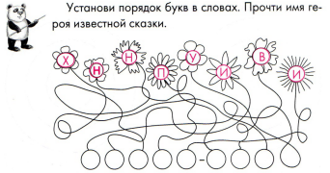

1. **Домик Винни-Пуха.**

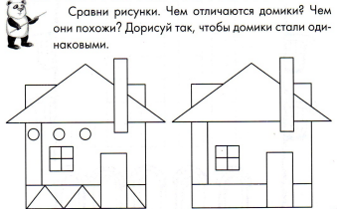

1. **Магические квадраты.**

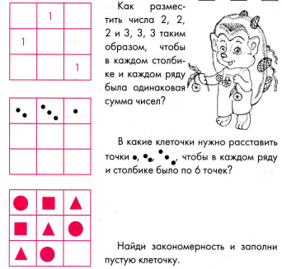

1. **Приключения Винни-Пуха**

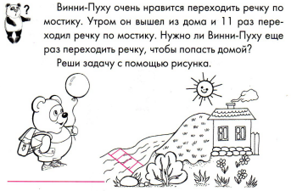

1. **Винни-Пух и Пятачок**

